A Recipe For:

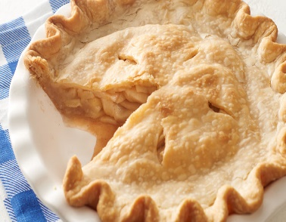 

# Perfect Apple Pie

**From the Kitchen of:** Mom

**Servings:** 1 pie

**Prep Time:** **Bake Time: 50 min** **Bake Temp:** 400

**Ingredients:**

* 6 to 8 tart apples, pared, cored and thinly sliced (6 cups) I use Granny Smith
* ¾ cup sugar
* 2 Tbsp all-purpose flour
* ½ to 1 tsp ground cinnamon
* Dash of nutmeg
* Pastry for 2-crust 9-inch pie
* 2 Tbsp butter

Combine sugar, flour, spices and dash of salt. Mix with apples. Line a 9- inch pie plate with pastry. Fill with apple mixture. Dot with butter. Place the top pastry on top of the apples cutting slits for escaping steam. Seal by pinching the top and the bottom of the crust together around the pie pan. Cut off excess pastry. Brush a little milk on top of the pastry and sprinkle with sugar.

Bake at 400 for 50 minutes or til done.

**Place the pie pan on a cookie sheet for baking so that if the juices flow over it won’t get your oven messy.